**Task1:**

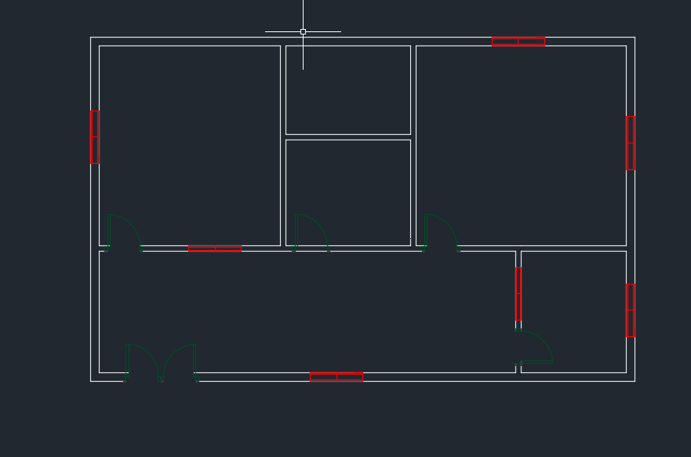

**Commands:**

|  |
| --- |
| Specify second point or [Array/Exit/Undo] <Exit>: *Cancel*  Command:  Command: _.erase 1 found  Command:  Command:  Command:  Command: _move 1 found  Specify base point or [Displacement] <Displacement>:  Specify second point or <use first point as displacement>:  Command: Specify opposite corner or [Fence/WPolygon/CPolygon]:  Command:  Command:  Command: _copy 1 found  Current settings: Copy mode = Multiple  Specify base point or [Displacement/mOde] <Displacement>:  Specify second point or [Array] <use first point as displacement>:  Specify second point or [Array/Exit/Undo] <Exit>: *Cancel*  Command: Specify opposite corner or [Fence/WPolygon/CPolygon]:  Command: Specify opposite corner or [Fence/WPolygon/CPolygon]:  Window Lasso Press Spacebar to cycle options  Crossing Lasso Press Spacebar to cycle options  Crossing Lasso Press Spacebar to cycle options  Command: _.erase 1 found  Command:  Command:  Command:  Command: _copy 1 found  Current settings: Copy mode = Multiple  Specify base point or [Displacement/mOde] <Displacement>:  Specify second point or [Array] <use first point as displacement>:  Specify second point or [Array/Exit/Undo] <Exit>: *Cancel*  Command:  Command:  Command: _arc  Specify start point of arc or [Center]:  Specify second point of arc or [Center/End]: *Cancel*  Command: <Ortho off>  Command:  Command:  Command: _arc  Specify start point of arc or [Center]:  Specify second point of arc or [Center/End]:  Specify end point of arc:  Command:  ARC  Specify start point of arc or [Center]: *Cancel*  Command:  Command:  Command:  Command: _move 1 found  Specify base point or [Displacement] <Displacement>: <Ortho on>  Specify second point or <use first point as displacement>:  Command: *Cancel*  Window Lasso Press Spacebar to cycle options  Window Lasso Press Spacebar to cycle options  Crossing Lasso Press Spacebar to cycle options  Command: Specify opposite corner or [Fence/WPolygon/CPolygon]:  Command:  Command:  Command: _copyclip 5 found  Command:  Command:  Command: _pasteclip Specify insertion point:  Command:  Press ESC or ENTER to exit, or right-click to display shortcut menu.  Command:  Command:  Command: _pasteclip Specify insertion point:  Command:  Command:  Command: _pasteclip Specify insertion point:  Command: Specify opposite corner or [Fence/WPolygon/CPolygon]:  Crossing Lasso Press Spacebar to cycle options  Command:  Command:  Command: _mirror 5 found  Specify first point of mirror line:  Specify second point of mirror line:  Erase source objects? [Yes/No] <No>: N  Command: _u INTELLIZOOM  Command: _u MIRROR GROUP  Crossing Lasso Press Spacebar to cycle options  Command:  Command:  Command: _mirror 5 found  Specify first point of mirror line:  Specify second point of mirror line:  Erase source objects? [Yes/No] <No>: *Cancel*  Crossing Lasso Press Spacebar to cycle options  Crossing Lasso Press Spacebar to cycle options  Command:  Command:  Command: _mirror 5 found  Specify first point of mirror line:  Specify second point of mirror line:  Erase source objects? [Yes/No] <No>: N  Crossing Lasso Press Spacebar to cycle options  Command:  Command:  Command: _copyclip 10 found  Command:  Command:  Command: _pasteclip Specify insertion point:  >>Press ESC or ENTER to exit, or right-click to display shortcut menu.  Resuming PASTECLIP command.  Specify insertion point:  Window Lasso Press Spacebar to cycle options  Window Lasso Press Spacebar to cycle options  Crossing Lasso Press Spacebar to cycle options  Command: _.erase 4 found  Window Lasso Press Spacebar to cycle options  Command:  Command:  Command: _mirror 5 found  Specify first point of mirror line:  Specify second point of mirror line: *Cancel*  Command:  Press ESC or ENTER to exit, or right-click to display shortcut menu.  Command:  Press ESC or ENTER to exit, or right-click to display shortcut menu.  Command:  Command:  Command: _qnew  Command:  Command:  Command:  Command: _qsave  Window Lasso Press Spacebar to cycle options  Command:  Command:  Command: _rotate  Current positive angle in UCS: ANGDIR=counterclockwise ANGBASE=0  5 found  Specify base point:  Specify rotation angle or [Copy/Reference] <90>:  Command:  Window Lasso Press Spacebar to cycle options  Command:  Command:  Command: _rotate  Current positive angle in UCS: ANGDIR=counterclockwise ANGBASE=0  5 found  Specify base point:  Specify rotation angle or [Copy/Reference] <270>:  Window Lasso Press Spacebar to cycle options  Command:  Command:  Command: _copyclip 5 found  Command: Specify opposite corner or [Fence/WPolygon/CPolygon]:  Command: *Cancel*  Command:  Press ESC or ENTER to exit, or right-click to display shortcut menu.  Command:  Command:  Command:  Command: _move 1 found  Specify base point or [Displacement] <Displacement>:  Specify second point or <use first point as displacement>:  Command:  Command: Specify opposite corner or [Fence/WPolygon/CPolygon]:  Command: Specify opposite corner or [Fence/WPolygon/CPolygon]: *Cancel*  Command: _u MOVE GROUP  Command:  Command:  Command:  Command: _move 1 found  Specify base point or [Displacement] <Displacement>:  Specify second point or <use first point as displacement>:  Crossing Lasso Press Spacebar to cycle options  Command:  Command:  Command: _copyclip 6 found  Command: Specify opposite corner or [Fence/WPolygon/CPolygon]:  Command:  Command:  Command: _pasteclip Specify insertion point:  Window Lasso Press Spacebar to cycle options  Command:  Command:  Command: _rotate  Current positive angle in UCS: ANGDIR=counterclockwise ANGBASE=0  3 found  Specify base point:  Specify rotation angle or [Copy/Reference] <0>: _u  Requires valid numeric angle, second point, or option keyword.  Specify rotation angle or [Copy/Reference] <0>: *Cancel*  Command: _u ROTATE GROUP  Command: _u PASTECLIP GROUP  Window Lasso Press Spacebar to cycle options  Command:  Command:  Command: _rotate  Current positive angle in UCS: ANGDIR=counterclockwise ANGBASE=0  4 found  Specify base point:  Specify rotation angle or [Copy/Reference] <0>:  Crossing Lasso Press Spacebar to cycle options  Command:  Command:  Command: _rotate  Current positive angle in UCS: ANGDIR=counterclockwise ANGBASE=0  4 found  Specify base point:  Specify rotation angle or [Copy/Reference] <180>:  Window Lasso Press Spacebar to cycle options  Command:  Command:  Command: _mirror 4 found  Specify first point of mirror line:  Specify second point of mirror line:  Erase source objects? [Yes/No] <No>:  Command:  Command: _.erase 1 found  Command:  Command: Specify opposite corner or [Fence/WPolygon/CPolygon]:  Command: _.erase 1 found  Command:  Command: _.erase 1 found  Command:  Command: _.erase 1 found  Window Lasso Press Spacebar to cycle options  Command:  Command:  Command: _copyclip 6 found  Command: Specify opposite corner or [Fence/WPolygon/CPolygon]:  Command: *Cancel*  Command:  Command:  Command: _pasteclip Specify insertion point:  Window Lasso Press Spacebar to cycle options  Command: _.erase 5 found  Crossing Lasso Press Spacebar to cycle options  Command: _.erase 4 found  Command:  Command:  Command: _qsave  Command:  Command:  Command: _qsave  Crossing Lasso Press Spacebar to cycle options  Command:  Press ESC or ENTER to exit, or right-click to display shortcut menu.  Command: <Grid off>  Command:  Command: _trim  Current settings: Projection=UCS, Edge=None  Select cutting edges ... 7 found  Select object to trim or shift-select to extend or  [Fence/Crossing/Project/Edge/eRase/Undo]:  Select object to trim or shift-select to extend or  [Fence/Crossing/Project/Edge/eRase/Undo]:  Select object to trim or shift-select to extend or  [Fence/Crossing/Project/Edge/eRase/Undo]:  Select object to trim or shift-select to extend or  [Fence/Crossing/Project/Edge/eRase/Undo]:  Select object to trim or shift-select to extend or  [Fence/Crossing/Project/Edge/eRase/Undo]:  Select object to trim or shift-select to extend or  [Fence/Crossing/Project/Edge/eRase/Undo]: *Cancel*  Command: Specify opposite corner or [Fence/WPolygon/CPolygon]: *Cancel*  Command: _trim  Current settings: Projection=UCS, Edge=None  Select cutting edges ... 3 found  Select object to trim or shift-select to extend or  [Fence/Crossing/Project/Edge/eRase/Undo]: Specify opposite corner: Specify opposite corner: *Cancel*  Crossing Lasso Press Spacebar to cycle options  Command: _u TRIM GROUP  Command: _trim  Current settings: Projection=UCS, Edge=None  Select cutting edges ... 4 found  Select object to trim or shift-select to extend or  [Fence/Crossing/Project/Edge/eRase/Undo]:  Select object to trim or shift-select to extend or  [Fence/Crossing/Project/Edge/eRase/Undo]:  Select object to trim or shift-select to extend or  [Fence/Crossing/Project/Edge/eRase/Undo]: *Cancel*  Command:  Command: _trim  Current settings: Projection=UCS, Edge=None  Select cutting edges ... 12 found  Select object to trim or shift-select to extend or  [Fence/Crossing/Project/Edge/eRase/Undo]:  Select object to trim or shift-select to extend or  [Fence/Crossing/Project/Edge/eRase/Undo]:  Select object to trim or shift-select to extend or  [Fence/Crossing/Project/Edge/eRase/Undo]:  Select object to trim or shift-select to extend or  [Fence/Crossing/Project/Edge/eRase/Undo]:  Select object to trim or shift-select to extend or  [Fence/Crossing/Project/Edge/eRase/Undo]: *Cancel*  Command: |

**Task2:**

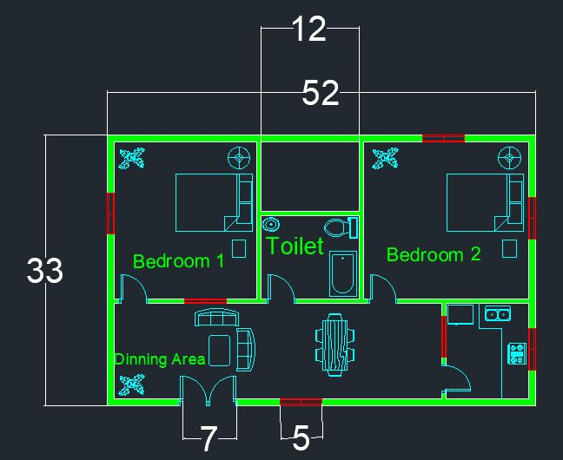

**Commands:**

|  |
| --- |
| Command:  Command: _move 1 found  Specify base point or [Displacement] <Displacement>:  Specify second point or <use first point as displacement>:  Command:  Command: _move 3 found  Specify base point or [Displacement] <Displacement>:  Specify second point or <use first point as displacement>:  Command: _u MOVE GROUP  Command:  Command: _copy 3 found  Current settings: Copy mode = Multiple  Specify base point or [Displacement/mOde] <Displacement>:  Specify second point or [Array] <use first point as displacement>:  Specify second point or [Array/Exit/Undo] <Exit>:  Command: _move 1 found  Specify base point or [Displacement] <Displacement>:  Specify second point or <use first point as displacement>:  Command: _move 1 found  Specify base point or [Displacement] <Displacement>:  Specify second point or <use first point as displacement>:  Command: _move 1 found  Specify base point or [Displacement] <Displacement>:  Specify second point or <use first point as displacement>:  Command: _rotate  Current positive angle in UCS: ANGDIR=counterclockwise ANGBASE=0  1 found  Specify base point:  Specify rotation angle or [Copy/Reference] <270>:  Command:  Command: _move 1 found  Specify base point or [Displacement] <Displacement>:  Specify second point or <use first point as displacement>:  Command:  Command: _.erase 1 found  Command: ADCENTER  Command:  Automatic save to C:\Users\bsee202124\appdata\local\temp\Lab11_1_1_4126.sv$ ...  Command: _move 1 found  Specify base point or [Displacement] <Displacement>:  Specify second point or <use first point as displacement>:  Command: _move 1 found  Specify base point or [Displacement] <Displacement>:  Specify second point or <use first point as displacement>:  Command: _move 1 found  Specify base point or [Displacement] <Displacement>:  Specify second point or <use first point as displacement>:  Command:  Command:  Command:  Command: _move 1 found  Specify base point or [Displacement] <Displacement>:  Specify second point or <use first point as displacement>:  Command: _move 1 found  Specify base point or [Displacement] <Displacement>:  Specify second point or <use first point as displacement>:  Command: '_dimstyle  Command: _dim  Select objects or specify first extension line origin or [Angular/Baseline/Continue/Ordinate/aliGn/Distribute/Layer/Undo]:'_.-LAYER  Current layer: "doorss"  >>Enter an option [?/Make/Set/New/Rename/ON/OFF/Color/Ltype/LWeight/TRansparency/MATerial/Plot/Freeze/Thaw/LOck/Unlock/stAte/Description/rEconcile]: _OFF  >>Enter name list of layer(s) to turn off or <select objects>: =walls  >>Enter an option [?/Make/Set/New/Rename/ON/OFF/Color/Ltype/LWeight/TRansparency/MATerial/Plot/Freeze/Thaw/LOck/Unlock/stAte/Description/rEconcile]:  Resuming DIM command.  *Cancel*  Command:  Command: _dim  Select objects or specify first extension line origin or [Angular/Baseline/Continue/Ordinate/aliGn/Distribute/Layer/Undo]:  Specify first extension line origin or [Angular/Baseline/Continue/Ordinate/aliGn/Distribute/Layer/Undo]:  Specify second extension line origin or [Undo]:  Specify dimension line location or second line for angle [Mtext/Text/text aNgle/Undo]:_u  Specify second extension line origin or [Undo]:*Cancel*  Command: '_dimstyle  Command: _trim  Current settings: Projection=UCS, Edge=None  Select cutting edges ... 4 found  Select object to trim or shift-select to extend or  [Fence/Crossing/Project/Edge/eRase/Undo]:  Select object to trim or shift-select to extend or  [Fence/Crossing/Project/Edge/eRase/Undo]:  Select object to trim or shift-select to extend or  [Fence/Crossing/Project/Edge/eRase/Undo]: *Cancel*  Command:  Press ESC or ENTER to exit, or right-click to display shortcut menu.  Command:  Command: '_.-LAYER  Current layer: "doorss"  Enter an option [?/Make/Set/New/Rename/ON/OFF/Color/Ltype/LWeight/TRansparency/MATerial/Plot/Freeze/Thaw/LOck/Unlock/stAte/Description/rEconcile]: _ON  Enter name list of layer(s) to turn on: =walls  Enter an option [?/Make/Set/New/Rename/ON/OFF/Color/Ltype/LWeight/TRansparency/MATerial/Plot/Freeze/Thaw/LOck/Unlock/stAte/Description/rEconcile]:  Command:  Command: _move 2 found  Specify base point or [Displacement] <Displacement>:  Specify second point or <use first point as displacement>: _u  Invalid point.  Specify second point or <use first point as displacement>: *Cancel*  Command: _move 1 found  Specify base point or [Displacement] <Displacement>:  Specify second point or <use first point as displacement>:  Command: _move 1 found  Specify base point or [Displacement] <Displacement>:  Specify second point or <use first point as displacement>:  Command: _rotate  Current positive angle in UCS: ANGDIR=counterclockwise ANGBASE=0  1 found  Specify base point:  Specify rotation angle or [Copy/Reference] <180>:  Command: _move 1 found  Specify base point or [Displacement] <Displacement>:  Specify second point or <use first point as displacement>:  Command: _move 1 found  Specify base point or [Displacement] <Displacement>:  Specify second point or <use first point as displacement>:  Command: _move 1 found  Specify base point or [Displacement] <Displacement>:  Specify second point or <use first point as displacement>:  Command: _move 1 found  Specify base point or [Displacement] <Displacement>:  Specify second point or <use first point as displacement>:  Command: _move 1 found  Specify base point or [Displacement] <Displacement>:  Specify second point or <use first point as displacement>:  Command: _copy 1 found  Current settings: Copy mode = Multiple  Specify base point or [Displacement/mOde] <Displacement>:  Checking 1128 intersections...  Specify second point or [Array] <use first point as displacement>:  Specify second point or [Array/Exit/Undo] <Exit>:  Command:  Crossing Lasso Press Spacebar to cycle options  Command: _.erase 5 found  Window Lasso Press Spacebar to cycle options  Window Lasso Press Spacebar to cycle options  Command: _.erase 7 found  Command:  Press ESC or ENTER to exit, or right-click to display shortcut menu.  Command: Specify opposite corner or [Fence/WPolygon/CPolygon]:  Command: _move 1 found  Specify base point or [Displacement] <Displacement>:  Specify second point or <use first point as displacement>:  Automatic save to C:\Users\bsee202134\appdata\local\temp\Lab11_1_1_4126.sv$ ...  Command: _line  Specify first point:  Command: '_.-LAYER  Current layer: "Doors"  >>Enter an option [?/Make/Set/New/Rename/ON/OFF/Color/Ltype/LWeight/TRansparency/MATerial/Plot/Freeze/Thaw/LOck/Unlock/stAte/Description/rEconcile]: _OFF  >>Enter name list of layer(s) to turn off or <select objects>: =walls  >>Enter an option [?/Make/Set/New/Rename/ON/OFF/Color/Ltype/LWeight/TRansparency/MATerial/Plot/Freeze/Thaw/LOck/Unlock/stAte/Description/rEconcile]:  Command: *Cancel*  Command:  Command: _line  Specify first point:  Specify next point or [Undo]: <Ortho on>  Specify next point or [Undo]:  Specify next point or [Close/Undo]:  >>Press ESC or ENTER to exit, or right-click to display shortcut menu.  Resuming LINE command.  Specify next point or [Close/Undo]:  Command: _line  Specify first point:  Specify next point or [Undo]:  >>Press ESC or ENTER to exit, or right-click to display shortcut menu.  Resuming LINE command.  Specify next point or [Undo]:  Specify next point or [Undo]: *Cancel*  Command:  Press ESC or ENTER to exit, or right-click to display shortcut menu.  Command: _line  Specify first point:  Specify next point or [Undo]:  Specify next point or [Undo]:  Specify next point or [Close/Undo]:  Specify next point or [Close/Undo]:  Command:  Command: '_.-LAYER  Current layer: "Doors"  Enter an option [?/Make/Set/New/Rename/ON/OFF/Color/Ltype/LWeight/TRansparency/MATerial/Plot/Freeze/Thaw/LOck/Unlock/stAte/Description/rEconcile]: _ON  Enter name list of layer(s) to turn on: =walls  Enter an option [?/Make/Set/New/Rename/ON/OFF/Color/Ltype/LWeight/TRansparency/MATerial/Plot/Freeze/Thaw/LOck/Unlock/stAte/Description/rEconcile]:  Command: '_dimstyle  Command:  Command:  Command: _dim  Select objects or specify first extension line origin or [Angular/Baseline/Continue/Ordinate/aliGn/Distribute/Layer/Undo]:  Specify first extension line origin or [Angular/Baseline/Continue/Ordinate/aliGn/Distribute/Layer/Undo]:  Specify second extension line origin or [Undo]:  Specify dimension line location or second line for angle [Mtext/Text/text aNgle/Undo]:_u  Specify second extension line origin or [Undo]:*Cancel*  Command:  Command:  Command: _mtext  Current text style: "Standard" Text height: 1/4" Annotative: No  Specify first corner: '_style  Resuming MTEXT command.  Specify first corner: *Cancel*  Command:  Command: _mtext  Current text style: "Standard" Text height: 1/4" Annotative: No  Specify first corner:  Specify opposite corner or [Height/Justify/Line spacing/Rotation/Style/Width/Columns]:  Command:  Command:  Command: _mtext  Current text style: "Standard" Text height: 1/4" Annotative: No  Specify first corner:  Specify opposite corner or [Height/Justify/Line spacing/Rotation/Style/Width/Columns]:  Command:  Command:  Command:  Command: _scale 1 found  Specify base point:  Specify scale factor or [Copy/Reference]:  Command:  Command: Specify opposite corner or [Fence/WPolygon/CPolygon]:  Command:  Specify first extension line origin or [Angular/Baseline/Continue/Ordinate/aliGn/Distribute/Layer/Undo]:  Specify second extension line origin or [Undo]:  Specify dimension line location or second line for angle [Mtext/Text/text aNgle/Undo]:  Select objects or specify first extension line origin or [Angular/Baseline/Continue/Ordinate/aliGn/Distribute/Layer/Undo]:  Specify first extension line origin or [Angular/Baseline/Continue/Ordinate/aliGn/Distribute/Layer/Undo]:  Specify second extension line origin or [Undo]:  Specify dimension line location or second line for angle [Mtext/Text/text aNgle/Undo]:*Cancel*  Automatic save to C:\Users\bsee202124\appdata\local\temp\Lab11_1_1_9874.sv$ ...  Command: _dim  Select objects or specify first extension line origin or [Angular/Baseline/Continue/Ordinate/aliGn/Distribute/Layer/Undo]:  Specify first extension line origin or [Angular/Baseline/Continue/Ordinate/aliGn/Distribute/Layer/Undo]:  Specify second extension line origin or [Undo]:  Specify dimension line location or second line for angle [Mtext/Text/text aNgle/Undo]:  Select objects or specify first extension line origin or [Angular/Baseline/Continue/Ordinate/aliGn/Distribute/Layer/Undo]:  Specify first extension line origin or [Angular/Baseline/Continue/Ordinate/aliGn/Distribute/Layer/Undo]:  Specify second extension line origin or [Undo]:  Specify dimension line location or second line for angle [Mtext/Text/text aNgle/Undo]:  Select objects or specify first extension line origin or [Angular/Baseline/Continue/Ordinate/aliGn/Distribute/Layer/Undo]:  Specify first extension line origin or [Angular/Baseline/Continue/Ordinate/aliGn/Distribute/Layer/Undo]:  Specify second extension line origin or [Undo]:  Specify dimension line location or second line for angle [Mtext/Text/text aNgle/Undo]:  Select objects or specify first extension line origin or [Angular/Baseline/Continue/Ordinate/aliGn/Distribute/Layer/Undo]:  Specify first extension line origin or [Angular/Baseline/Continue/Ordinate/aliGn/Distribute/Layer/Undo]:  Specify second extension line origin or [Undo]:  Specify dimension line location or second line for angle [Mtext/Text/text aNgle/Undo]:  Select objects or specify first extension line origin or [Angular/Baseline/Continue/Ordinate/aliGn/Distribute/Layer/Undo]:  Specify first extension line origin or [Angular/Baseline/Continue/Ordinate/aliGn/Distribute/Layer/Undo]:  Specify second extension line origin or [Undo]:  Specify dimension line location or second line for angle [Mtext/Text/text aNgle/Undo]:  Select objects or specify first extension line origin or [Angular/Baseline/Continue/Ordinate/aliGn/Distribute/Layer/Undo]:  Specify first extension line origin or [Angular/Baseline/Continue/Ordinate/aliGn/Distribute/Layer/Undo]:  Specify second extension line origin or [Undo]:  Specify dimension line location or second line for angle [Mtext/Text/text aNgle/Undo]:  Specify how to handle overlapping dimensions [Move away/Break up/Replace/None] <Move away>:*Cancel*  Select objects or specify first extension line origin or [Angular/Baseline/Continue/Ordinate/aliGn/Distribute/Layer/Undo]:  Select objects or specify first extension line origin or [Angular/Baseline/Continue/Ordinate/aliGn/Distribute/Layer/Undo]:  Command:  Command: '_.-LAYER  Current layer: "doorss"  Enter an option [?/Make/Set/New/Rename/ON/OFF/Color/Ltype/LWeight/TRansparency/MATerial/Plot/Freeze/Thaw/LOck/Unlock/stAte/Description/rEconcile]: _ON  Enter name list of layer(s) to turn on: =walls  Enter an option [?/Make/Set/New/Rename/ON/OFF/Color/Ltype/LWeight/TRansparency/MATerial/Plot/Freeze/Thaw/LOck/Unlock/stAte/Description/rEconcile]:  Command: *Cancel*  Command:  Automatic save to C:\Users\bsee202124\appdata\local\temp\Lab11_1_1_9874.sv$ ...  Command: |

**Practice Task:**

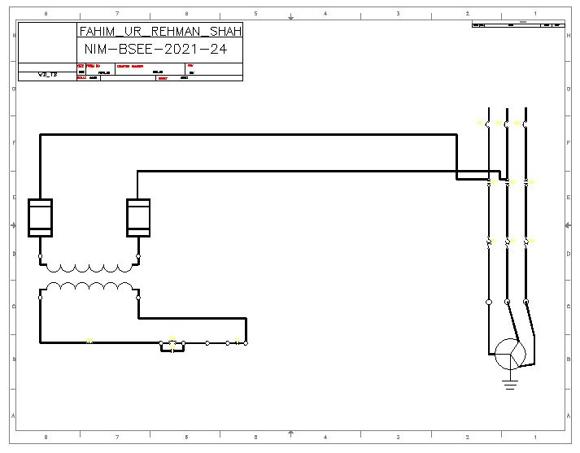

**Commands:**

|  |
| --- |
| Command:  Command: _move 1 found  Specify base point or [Displacement] <Displacement>:  Specify second point or <use first point as displacement>:  Command: _move 3 found  Specify base point or [Displacement] <Displacement>:  Specify second point or <use first point as displacement>:  Command: _u MOVE GROUP  Command: _copy 3 found  Current settings: Copy mode = Multiple  Specify base point or [Displacement/mOde] <Displacement>:  Specify second point or [Array] <use first point as displacement>:  Specify second point or [Array/Exit/Undo] <Exit>:  Command: _move 1 found  Specify base point or [Displacement] <Displacement>:  Specify second point or <use first point as displacement>:  Command:  Command: _move 1 found  Specify base point or [Displacement] <Displacement>:  Specify second point or <use first point as displacement>:  Command:  Command: _move 1 found  Specify base point or [Displacement] <Displacement>:  Specify second point or <use first point as displacement>:  Command: _rotate  Current positive angle in UCS: ANGDIR=counterclockwise ANGBASE=0  1 found  Specify base point:  Specify rotation angle or [Copy/Reference] <270>:  Command: _move 1 found  Specify base point or [Displacement] <Displacement>:  Specify second point or <use first point as displacement>:  Command:  Command: _.erase 1 found  Command: ADCENTER  Automatic save to C:\Users\bsee202124\appdata\local\temp\Lab11_1_1_4126.sv$ ...  Command: _move 1 found  Specify base point or [Displacement] <Displacement>:  Specify second point or <use first point as displacement>:  Command:  Command: _move 1 found  Specify base point or [Displacement] <Displacement>:  Specify second point or <use first point as displacement>:  Command: _move 1 found  Specify base point or [Displacement] <Displacement>:  Specify second point or <use first point as displacement>:  Command: _move 1 found  Specify base point or [Displacement] <Displacement>:  Specify second point or <use first point as displacement>:  Command: _move 1 found  Specify base point or [Displacement] <Displacement>:  Specify second point or <use first point as displacement>:  Command: '_dimstyle  Command: _dim  Select objects or specify first extension line origin or [Angular/Baseline/Continue/Ordinate/aliGn/Distribute/Layer/Undo]:'_.-LAYER  >>Enter an option [?/Make/Set/New/Rename/ON/OFF/Color/Ltype/LWeight/TRansparency/MATerial/Plot/Freeze/Thaw/LOck/Unlock/stAte/Description/rEconcile]: _OFF  >>Enter name list of layer(s) to turn off or <select objects>: =walls  >>Enter an option [?/Make/Set/New/Rename/ON/OFF/Color/Ltype/LWeight/TRansparency/MATerial/Plot/Freeze/Thaw/LOck/Unlock/stAte/Description/rEconcile]:  Resuming DIM command.  *Cancel*  Command:  Command: _dim  Select objects or specify first extension line origin or [Angular/Baseline/Continue/Ordinate/aliGn/Distribute/Layer/Undo]:  Specify first extension line origin or [Angular/Baseline/Continue/Ordinate/aliGn/Distribute/Layer/Undo]:  Specify second extension line origin or [Undo]:  Specify dimension line location or second line for angle [Mtext/Text/text aNgle/Undo]:_u  Specify second extension line origin or [Undo]:*Cancel*  Command: '_dimstyle  Command:  Select objects or specify first extension line origin or [Angular/Baseline/Continue/Ordinate/aliGn/Distribute/Layer/Undo]:  Command:  Enter an option [?/Make/Set/New/Rename/ON/OFF/Color/Ltype/LWeight/TRansparency/MATerial/Plot/Freeze/Thaw/LOck/Unlock/stAte/Description/rEconcile]: _ON  Enter name list of layer(s) to turn on: =walls  Enter an option [?/Make/Set/New/Rename/ON/OFF/Color/Ltype/LWeight/TRansparency/MATerial/Plot/Freeze/Thaw/LOck/Unlock/stAte/Description/rEconcile]:  Command: *Cancel*  Command:  Automatic save to C:\Users\bsee202124\appdata\local\temp\Lab11_1_1_9874.sv$ ...  Command: |